SITE VISIT REPORT
Date | Monday, June 8, 2026
Project | Maple Grove Office Park, Bldg A
Project address | 2418 Maple Grove Way, Highland Park, CA 90035
Inspector | Ryan Ghods, Bayfront Engineering

#1  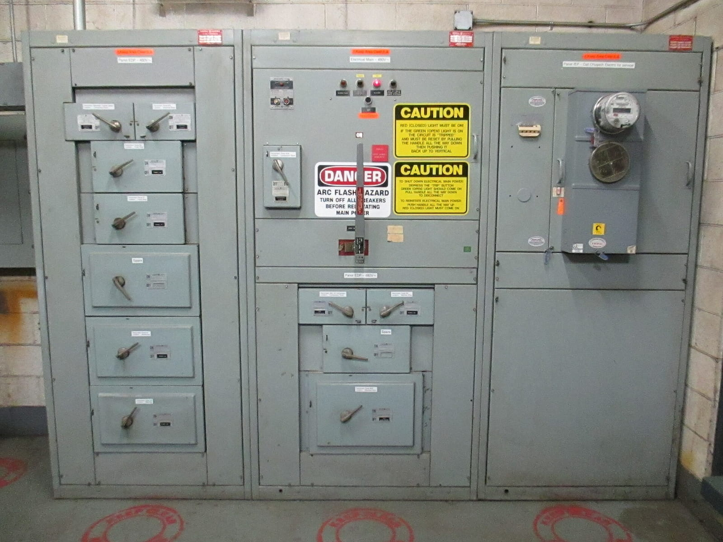 | Bldg A main 480V distribution lineup, west corridor service room. Incoming feeder lands left of the main disconnect; spare 100A breaker space is reserved for the future Suite 203 tenant.  Main distribution is on the west corridor wall, four eighty three-phase. Need the electrical sub to leave a hundred-amp breaker space for the future Suite two oh three tenant before we close the room.
#2  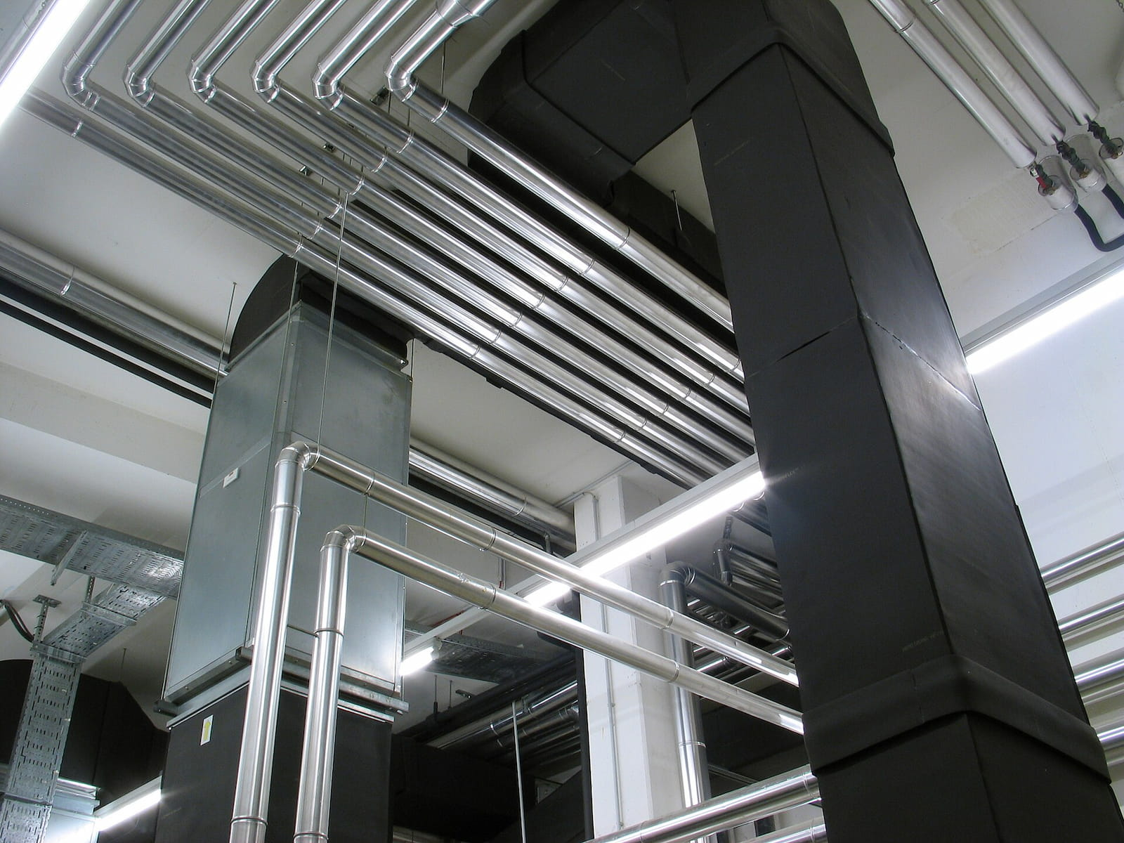 | Floor 2 overhead chilled-water mains above the central corridor. Confirm hangers fall on the structural beams, not the metal deck.
#3
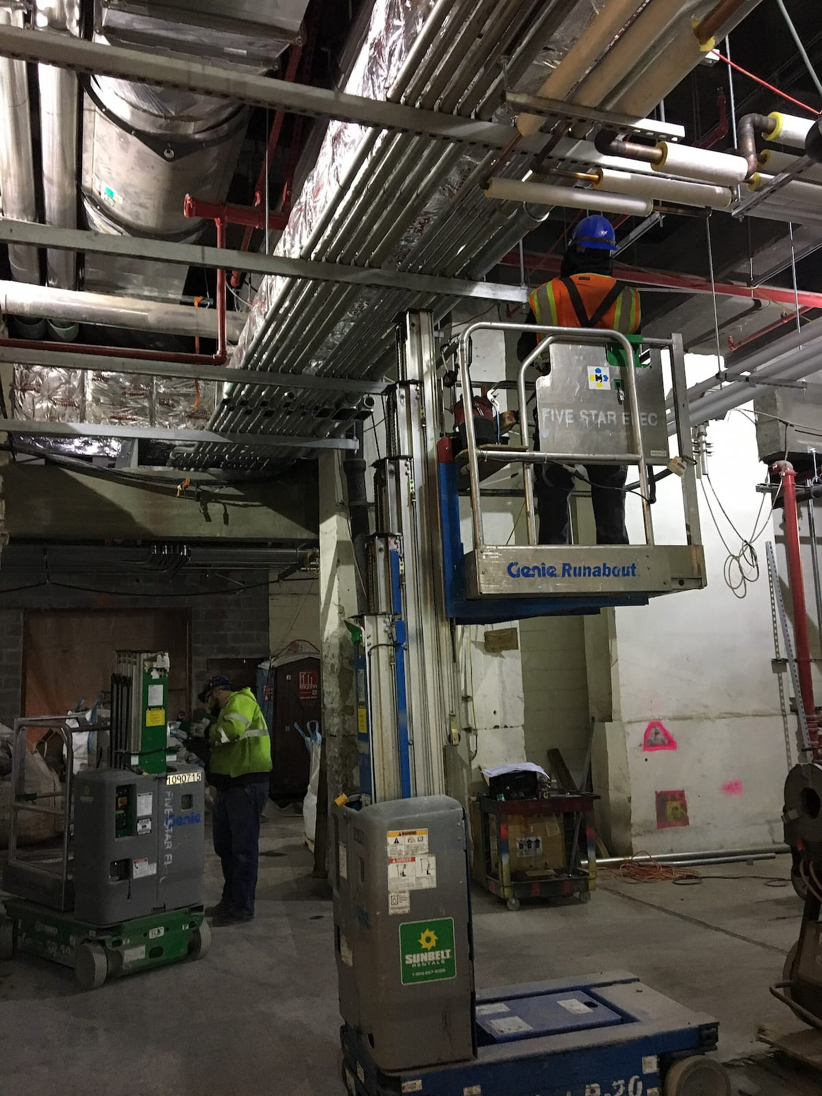
#4  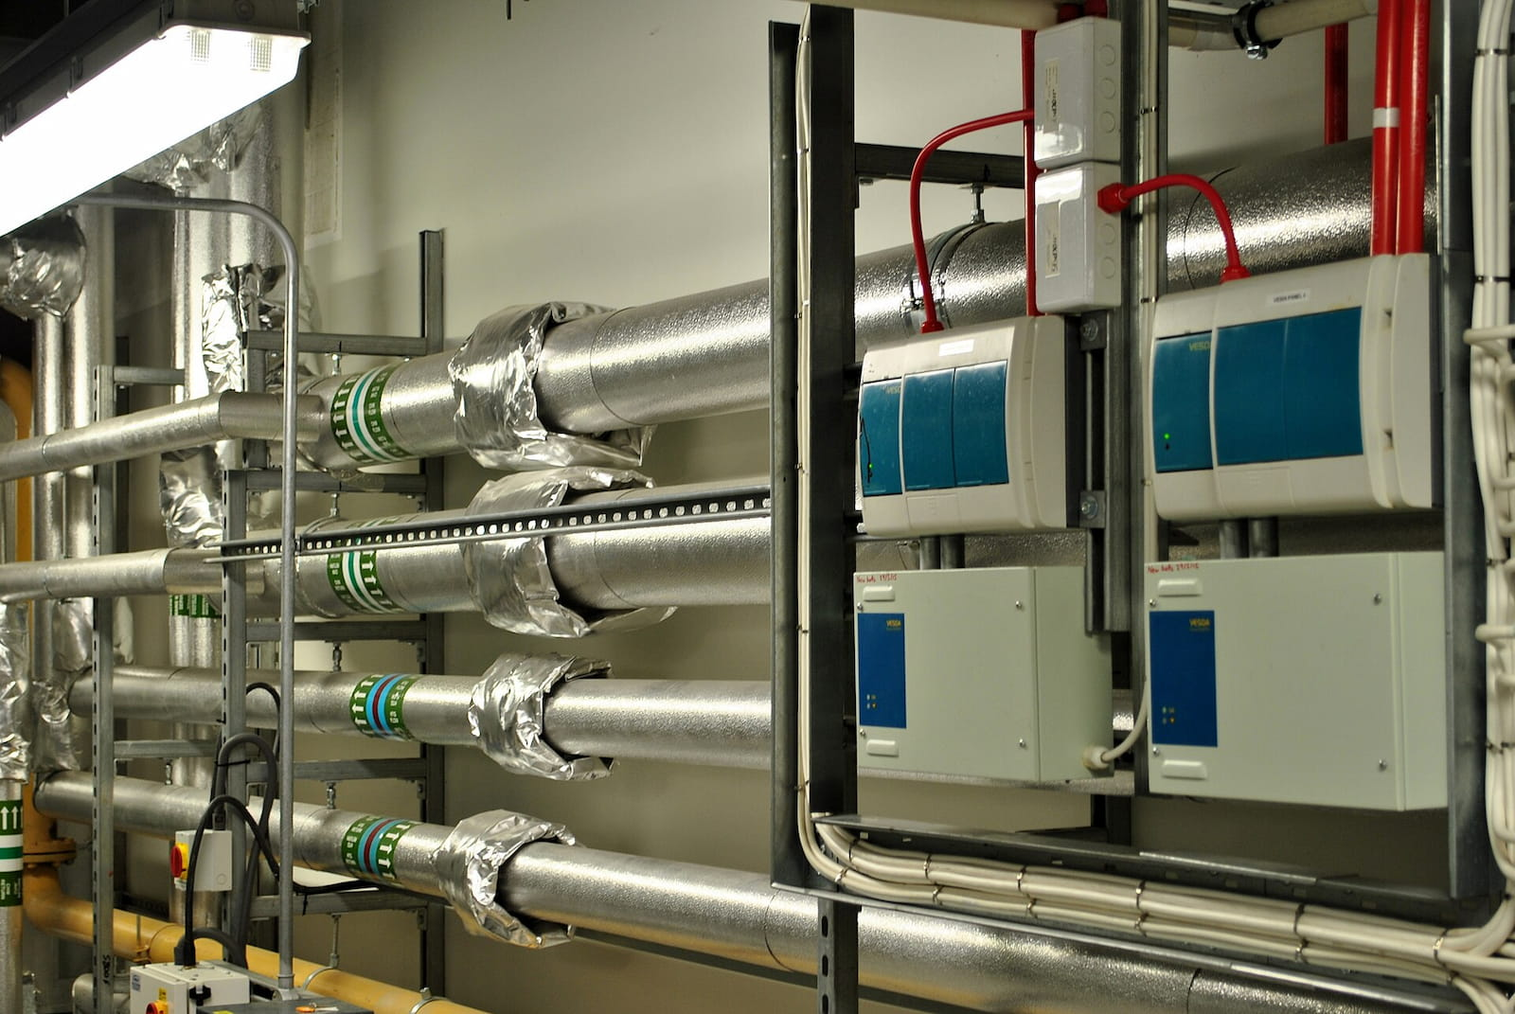 | Floor 2 mech room, chilled-water primary mains. BMS controllers wall-mounted above the unit, but the lav vent stack from the tenant restroom comes up through this chase. Flag clash for mechanical sub before insulation wrap.  Floor two mech room chase, behind the tenant restroom wet wall. The lav vent stack lands right where the BMS conduit run wants to go. Flag this for the mechanical sub before they wrap the insulation.
#5
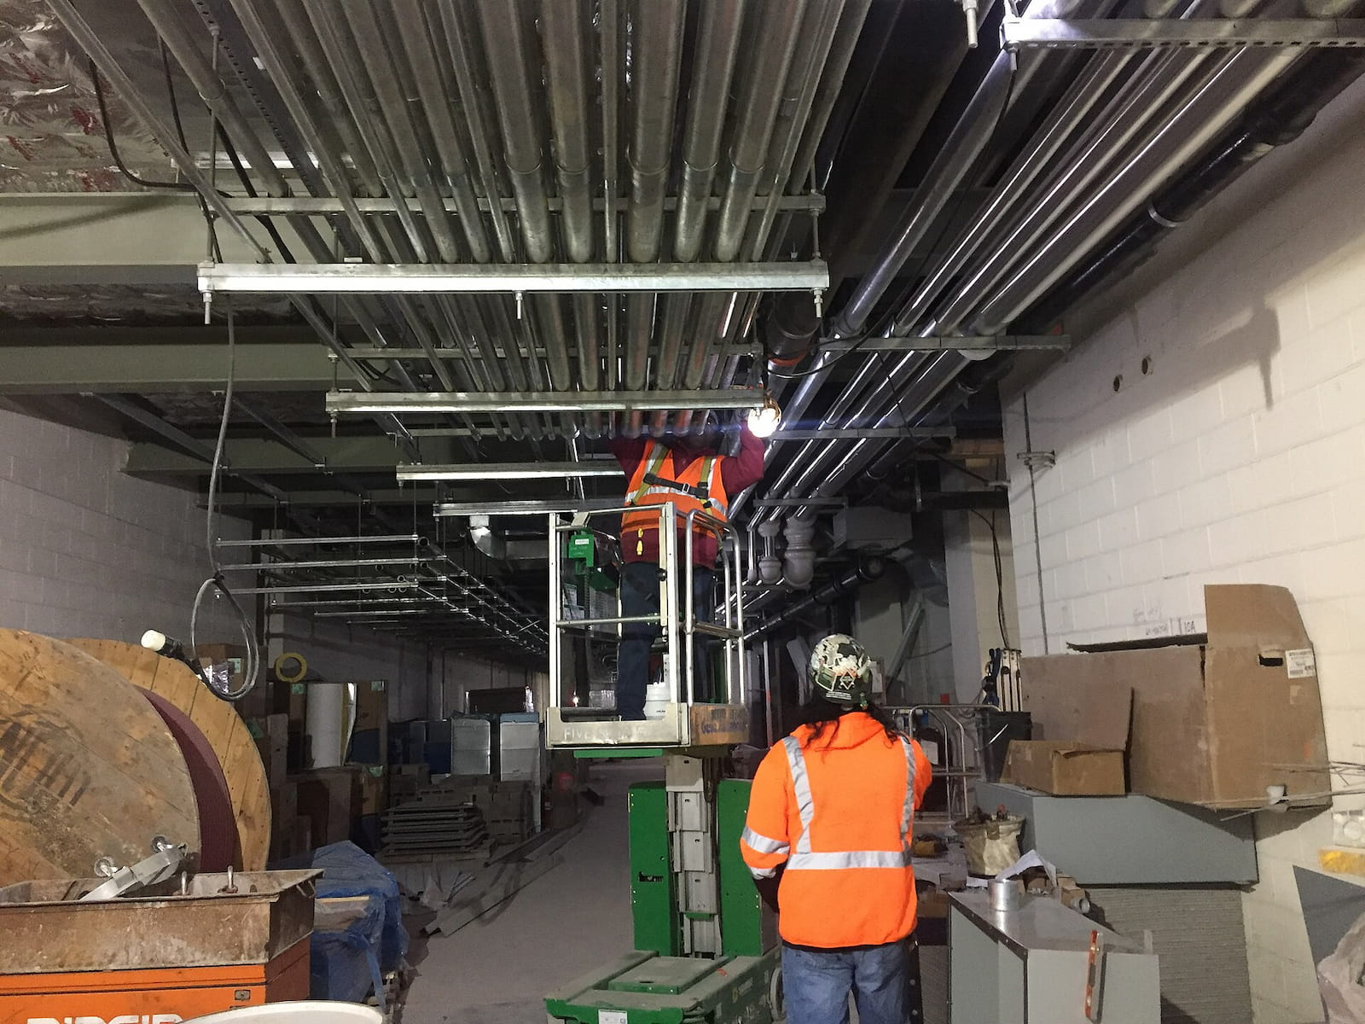
#6  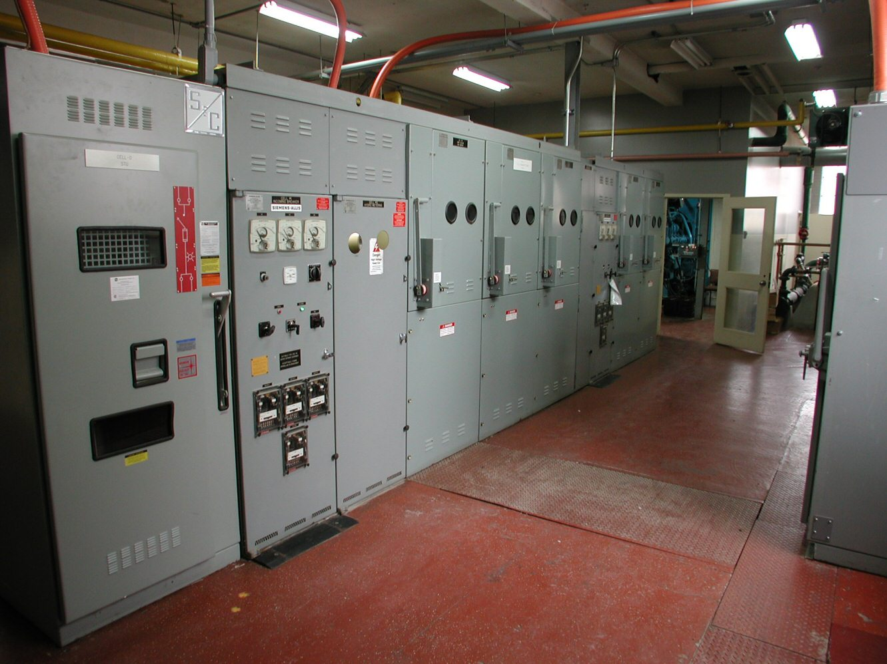 | North service room switchgear lineup, low-voltage section. Incoming feeder cell lands from the Bldg A main; verify 30" working depth at the rear cell against the structural drawings.  Floor 2 mech / switchgear coordination  Three coordination items after today's walk:  - Lav vent stack from the tenant restroom conflicts with the BMS conduit run above the unit controllers  - Cold-water supply stub at the mop sink is 4" low; verify before insulation wrap  - Rear-cell working depth at the north switchgear is 28" against the structural beam; need 30" per the spec  Recommend a coordination walk with the plumbing, mechanical, and electrical subs before the ceiling grid is closed.

ADDITIONAL NOTES
Site access
Owner provided badge access through the loading dock. Re-up the badge before next Tuesday's follow-up walk.
Open punchlist
Three coordination items flagged today. Mechanical sub to confirm reroute drawings by EOW.

